**USER DOCUMENTATION**

‘INFORMAL DOMESTIC TRADE REGISTRATION SYSTEM’

March, 2019

VERSION: ‘NM.R1.0.0@2019’

Table of Contents

INTRODUCTION 2

User documentation 2

Target Audience 3

Key Features 3

Supported Web browsers 4

GETTING STARTED 4

1) Account Creation 4

2) User Login 6

3) Business Unit registration 10

4) Querying Existing Businesses (Select Query Criteria) 13

# INTRODUCTION

Documentations are a must in almost all projects (i.e. Software Development Projects, Construction Projects, Digitization Projects, etc. These documentations incorporate and are not limited to Process Documentations, Product Documentations, End-user Documentations, and so forth.

1. Processes documentation: These reports record the process of development and support. Process documents include – Plans documents, Schedules documents, Process Quality documents, and Organizational and Project standards documents.
2. Product documentation: Product documentation basically describe the product that is being developed. The description of the product from the point of view of the engineers developing and maintaining the system is referred to as System documentation.
3. User documentation: This provides a product description that is oriented towards system users. It basically helps users - experts or non-experts to have a brief understanding of the system as well as help with the navigation and general system use.

Process documentation is produced so that the development of the system can be managed and is an essential component of plan-driven approaches to software engineering. An important goal of agile approaches is to minimize the amount of process documentation produced as this adds overhead without contributing to the functionality of the system being developed.

Product documentation is used after the system is operational but is also essential for management of the system development. The creation of a document, such as a system specification, may represent an important milestone in the software development process.

For this project – ‘Informal Domestic Trade Registration System’, we will focus on the **‘User Documentation’**. The end-user documentation is designed to assist end users to use the product or service and is often referred to as user assistance. The user documentation is a part of the overall product delivered to the customer after project completion.

## User documentation

Users of a system are not all the same. The producer of the documentation must structure it to cater for different user tasks and different levels of expertise and experience.

User documentation is important because it provides an avenue for users to learn:

1. how to use your software
2. features of your software
3. tips and tricks of your software
4. how to resolve common problems with your software

Without user documentation, a user may not know how to do the above things.

Users expect the user documentation to include:

* FAQs
* Video tutorials
* Embedded assistance (for example, tool tips and dynamic page content)
* Support Portals
* Etc.

The ‘Informal Domestic Trade Registration System’ referred to as the **‘MoF – Vendor Business’** in this document offers web based registrations of all informal sector business units. It is also coupled with a massive database to be able to capture the entire population of Zambia with scalability capabilities. The rationale of this system is to facilitate for the capture of detailed information (i.e. number of informal business units, number of business units in each category, informal sector employment levels, etc.) on the informal sector by the Ministry of Finance for fiscal policy matters. This also helps the Ministry of Finance to be able to determine the informal sector’s contribution to the national economy.

## Target Audience

* Members of the general public
* Employees both formal and informal
* Directors and Chief Executive Officers
* Policy makers

## Key Features

* Easy to use (user friendly)
* Can be accessed from any computing system-desktop computers, laptops, mobile, etc. as long as such devices have internet connectivity
* Easy to create user accounts
* Easy to add any informal business units – street vending, regular and occassional markets, homestead stalls, etc.
* Massive storage capacity
* Can be accessed 24/7 throughout the year

## Supported Web browsers

* Microsoft IE7 or greater
* Mozilla Firefox
* Google Chrome
* Opera
* Microsoft Edge

# GETTING STARTED

1. Account Creation:

* Navigate to the web portal - <http://localhost/Vendor_Assignment/index.php> (see screenshot below)

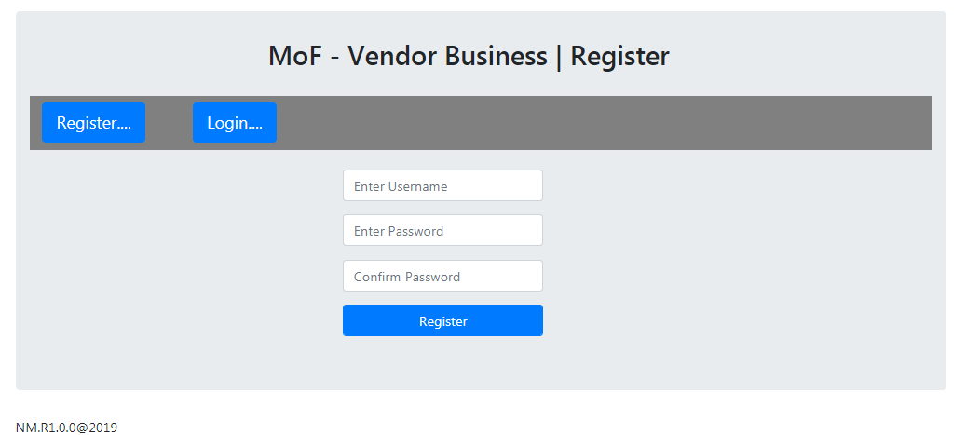

Figure 1.0 Registration Page

* The above page enables a user to register/create an account using the register button. This allows any Zambian to create an account on the MoF-Vendor Business.

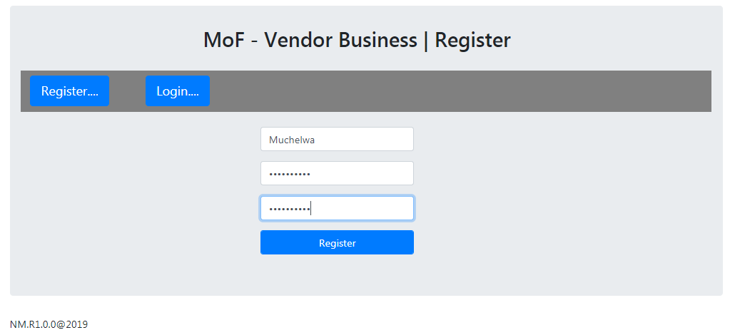

Figure 1.1 User named Muchelwa Registering on the system

* Input name and password – see above
* Click on Register button
* Successful registration (fig. 1.2)
* Unsuccessful registration (fig. 1.3)

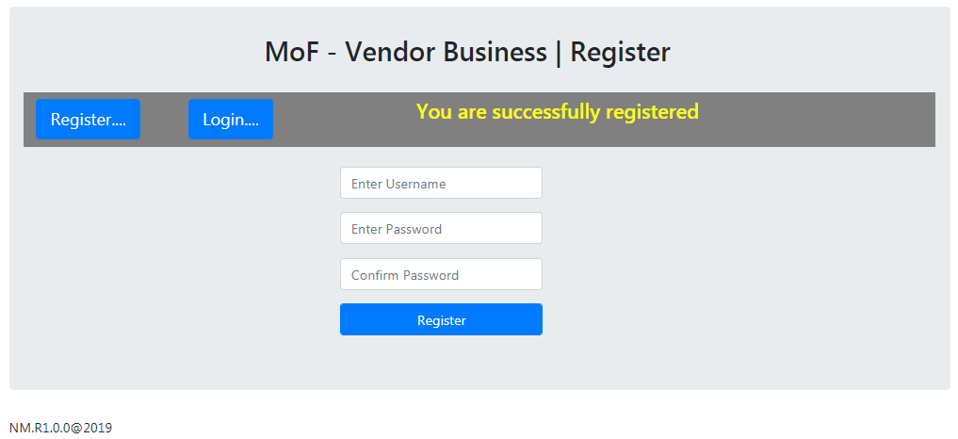

Figure 1.2 Successful Registration

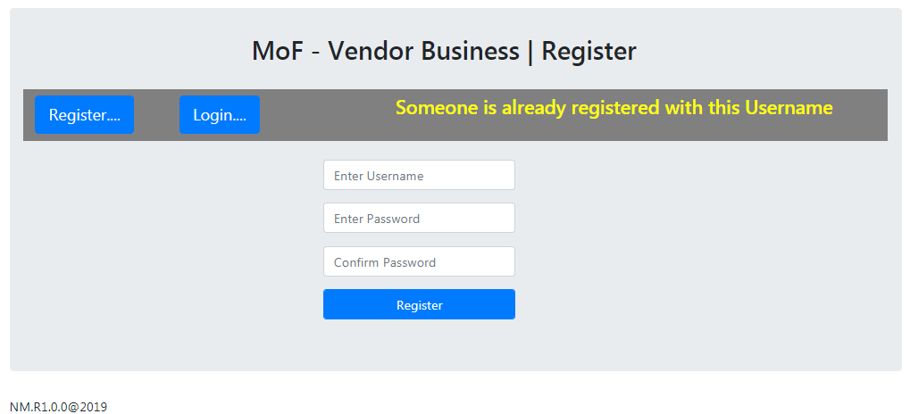

Figure 1.3 Unsuccessful Registration due already registered user

## User Login

* Navigate to: <http://localhost/Vendor_Assignment/login.php> (See below snapshot)

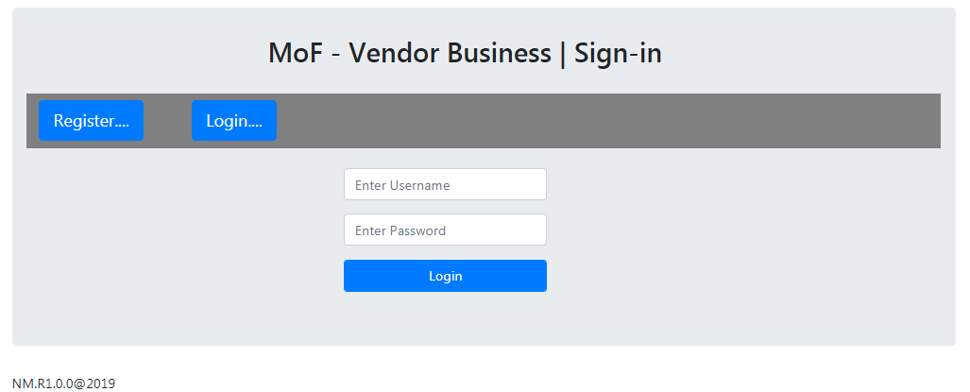

Figure 2.0 Sign-in/Login page

The Sign-in/Login page allows already registered users to have access to the Ministry of Finance - vendor business portal for purposes of either querying the Db for information relating to informal domestic trading. It can also be used to register an informal domestic trade with the Ministry of Finance.

* Input username and password – see figure 2.1
* Click on login button

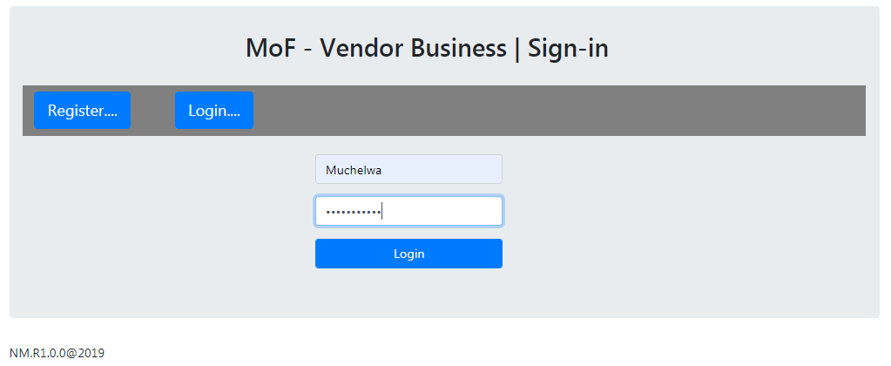

Figure 2.1 Signing/Logging in

* Once you click on the Login button, you will see the page below – figure 2.2 (if the credentials are correct)

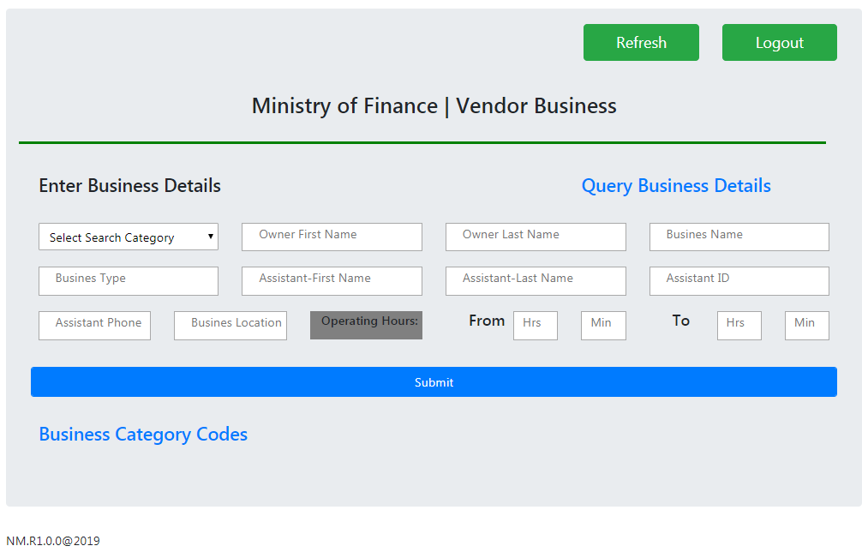

Figure 2.2 Successful Login

On this page an informal domestic trader can register their business by filling in the above form.

* Figure 2.3 shows response for incorrect password
* Figure 2.4 shows response for incorrect username

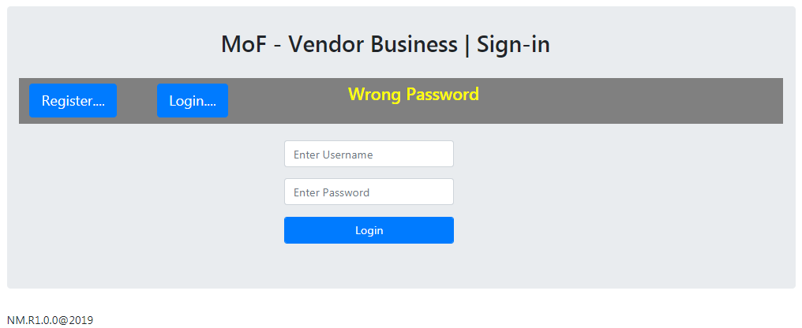

Figure 2.3 Unsuccessful Login due to wrong password

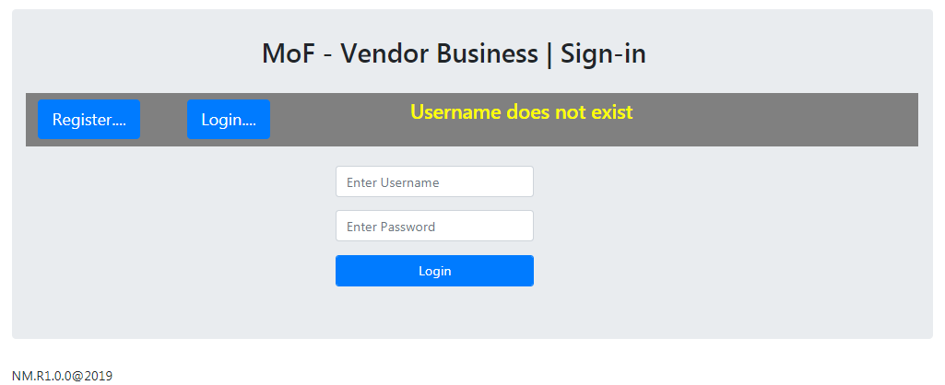

Figure 2.4 Username does not exist

1. Business Unit registration – Street Vending, Sale at regular and occasional markets e.g. Tuesday Market, and Homestead Stalls

* Input Business Category, Owner First name, Owner Last name, Business name, Business type, Assistant First name (optional), Assistant Last name (optional), Assistant ID, Assistant Phone no., Business location, and Operating Hours – see figure 3.0
* For Business Category, click Business Category Codes link

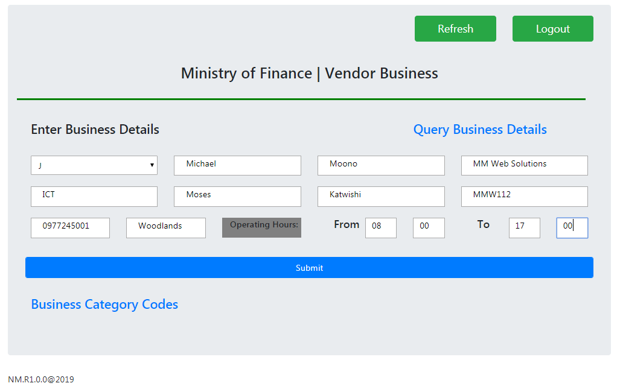

Figure 3.0 Registering a business on the vendor business portal

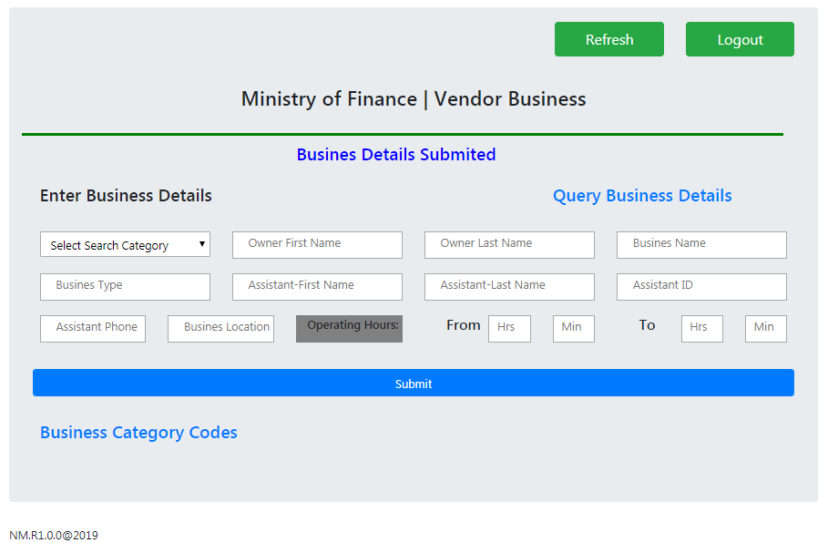

Figure 3.1 Successful Registration

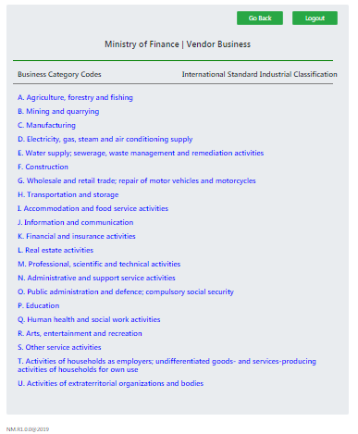

Figure 3.2 Business Category Codes-ISIC Rev.4

1. Querying Existing Businesses (Select Query Criteria) – See Figure 4.0. You can query and retrieve information from the database using any of the following criteria:

* Query All and click Query button
* Business Category e.g. A and click Query button
* Business Name e.g. Gampe and click Query button
* Business Type e.g. Agriculture and click Query button
* Owner first name e.g. Gabriel and click Query button, and
* Owner last name e.g. Kapumpe and click Query button – for all above queries, refer to Figure 4.1 for sample results

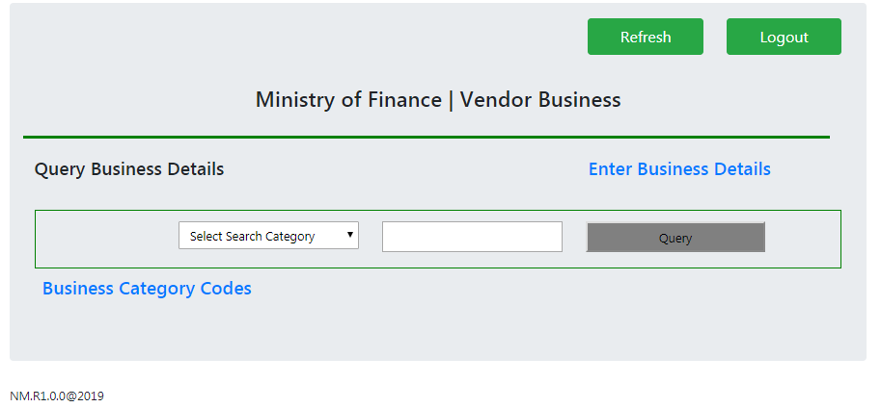

Figure 4.0 Querying Business Details from the Db

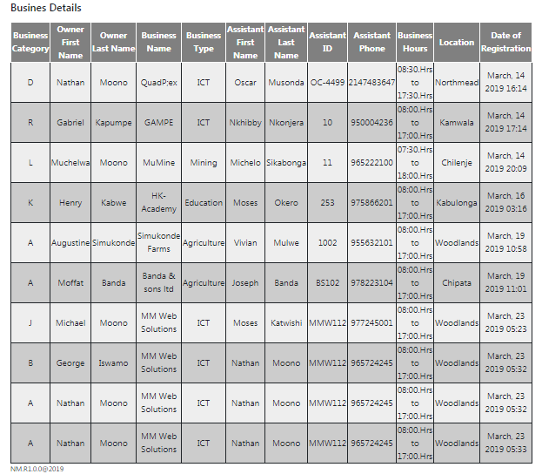

Figure 4.1 Sample registered businesses

Querying the Db using owner last name: You can query information relating to part or the whole last name of the owner (see figure below).

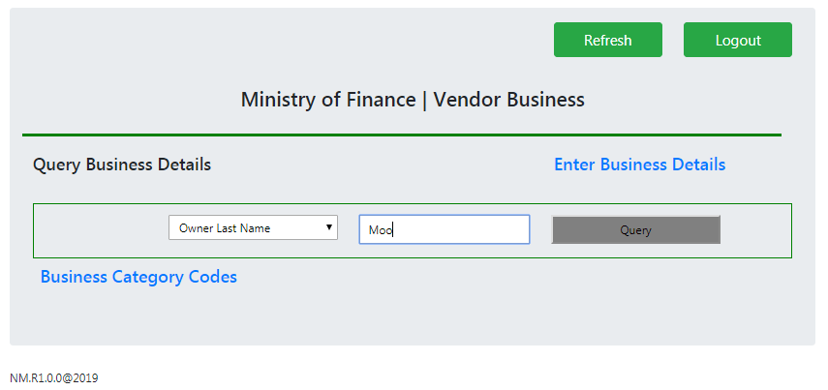

Figure 4.2 Querying using full/part of owner name

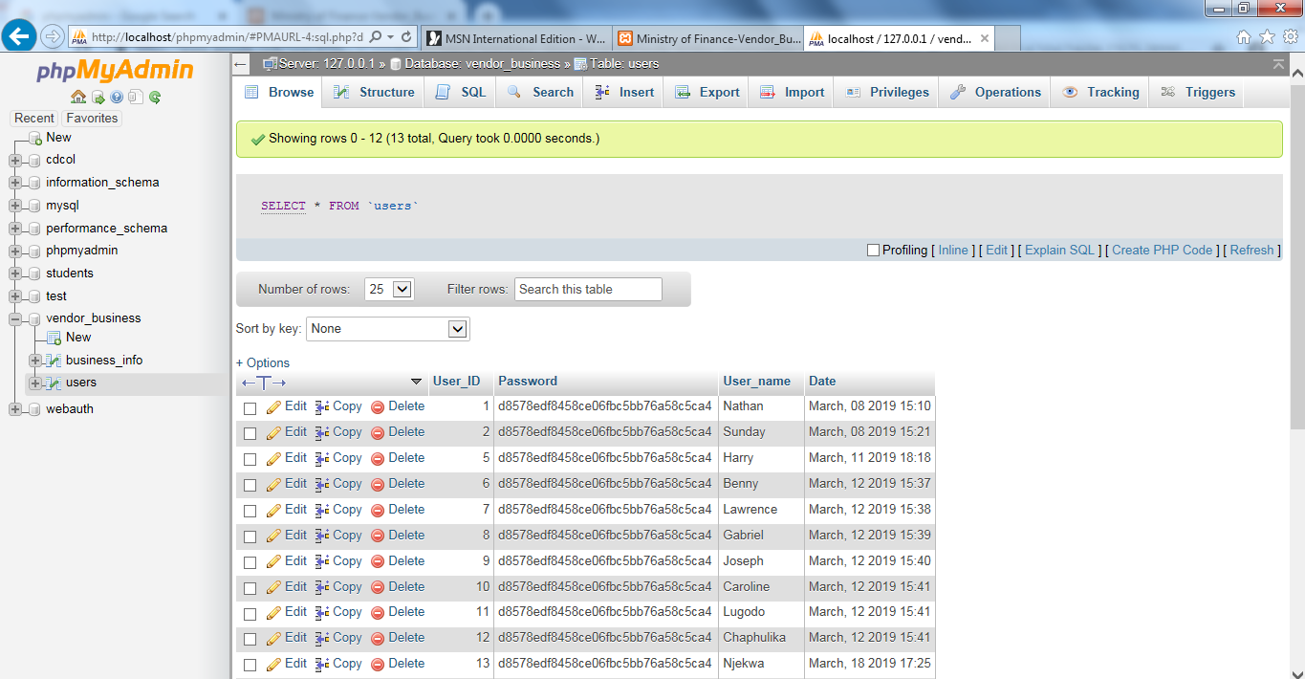

Figure 3.4 Registered users

*Blank Page*